**Assignment 2**

**Python Questions -:**

**1.Write a program using dictionary that accepts a string and change its lowercase vowels to special character as given below:**

**a #**

**e @**

**I $**

**o %**

**u !**

dic={

'a':'#',

'e':'@',

'i':'$',

'o':'%'

'u':'!',

}

str=input("enter a string:")

newstr=""

for x in str:

if(x=='a'or x=='e' or x=='i' or x=='o' or x=='u'):

newstr+=dic[x]

else:

newstr+=x

print(newstr)

**output-**

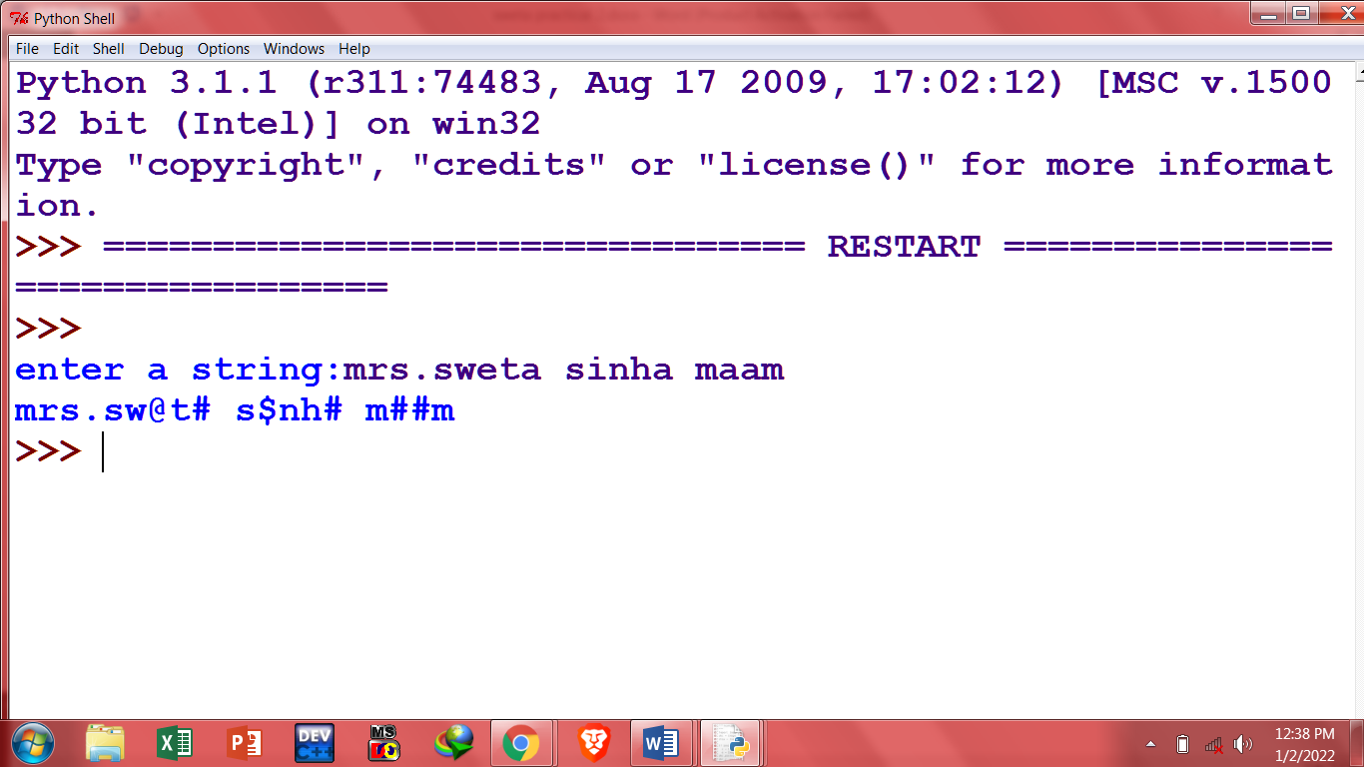

**2.Write a program that reads two strings from keyboard and prints the common words. Your program should convert input string to lower case.**

str1=input("enter a string1")

str2=input("enter string 2")

str1=str1.lower()

str2=str2.lower()

temp=''

str1list=str1.split(" ")

for i in str1list:

check=str2.find(i)

if(check!=-1):

print(i)

**output-**

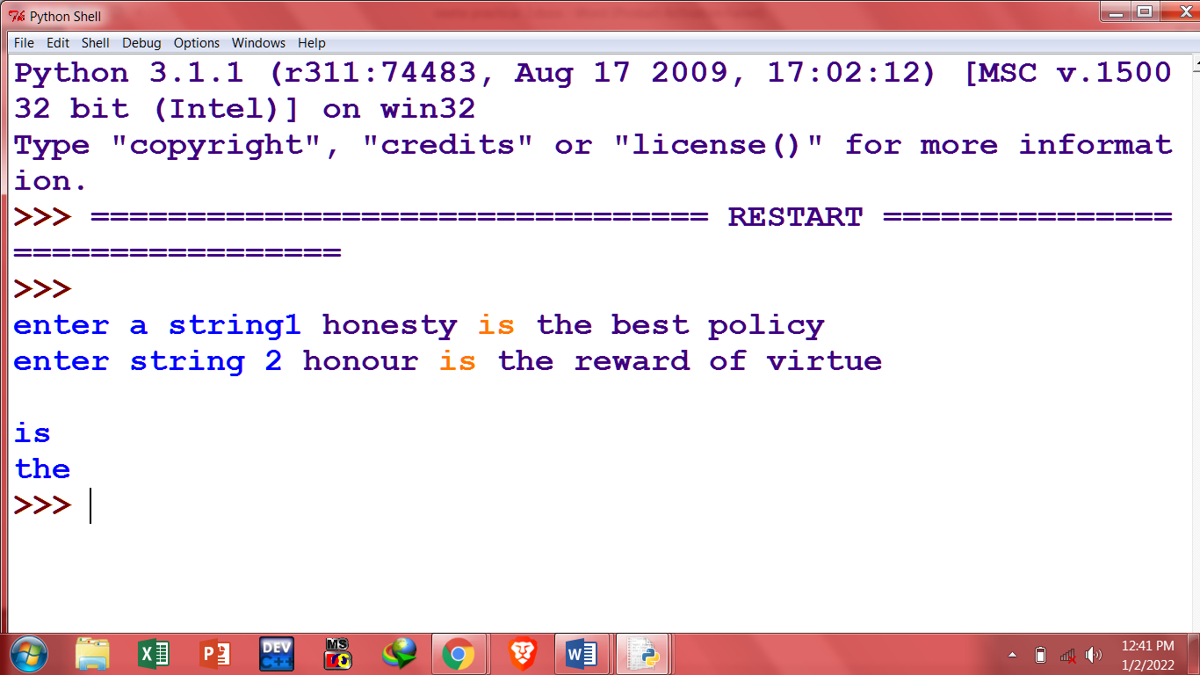

**3. Write a program that keeps student's name and his marks in a dictionary as key-value pairs. The program should store records of 10 students and display students name and marks of five students in decreasing order of marks obtained.**

std={

"vk":23,

"dk":34,

"ck":32,

"pc":100,

"kk":19,

"cc":8,

}

sortData=sorted(std.items(),reverse=True, key =lambda kv:(kv[1], kv[0]))

print(sortData)

**output-**

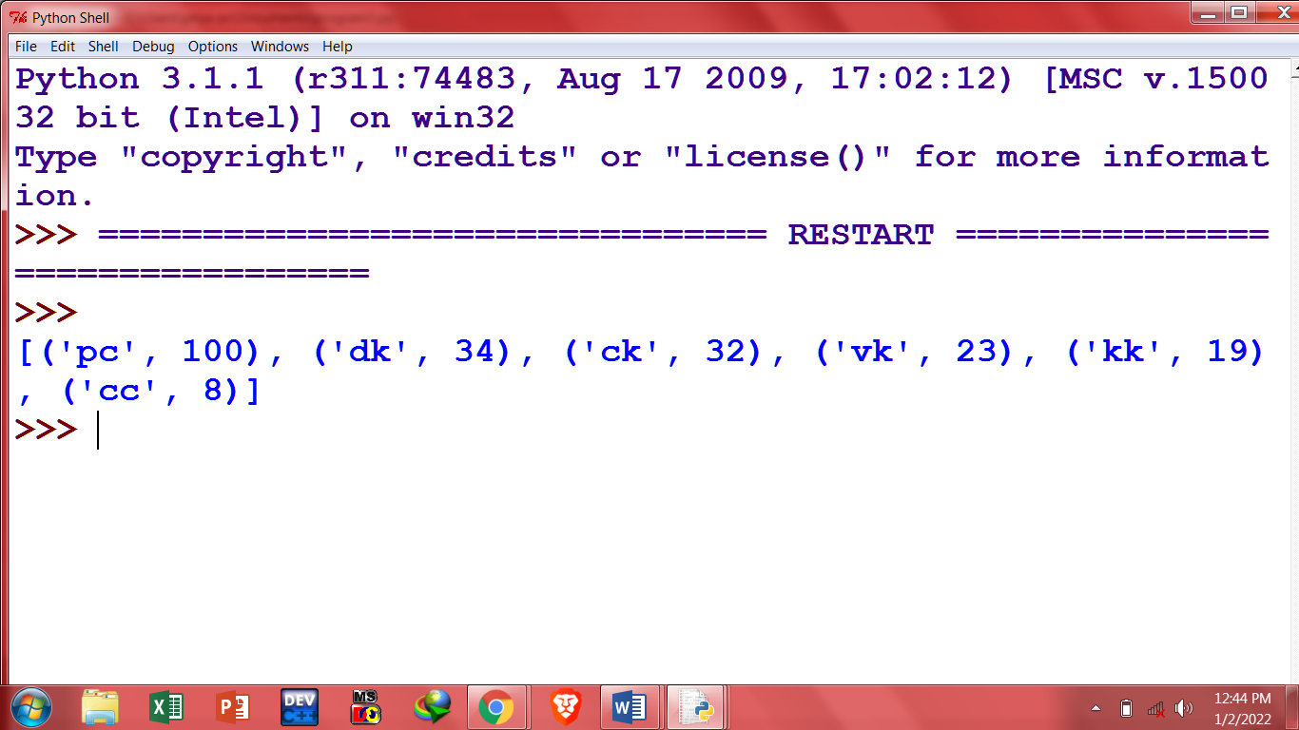

**4.In a text editing software , after saving the article as WORDS.TXT, it is realised that alphabet I is wrongly typed as alphabet J everywhere in the article. Write a function definition for convert() in Python that would display the corrected version of entire content of the file WORDS.TXT with all the alphabets "J" to be displayed as an alphabet "I" on screen.**

f=open("WORDS.TXT","r")

str=f.read()

print("before fixing:")

print(str)

print ("after fixing:")

for x in str:

if(x=='j'):

print("i",end="")

else:

print(x,end="")

f.close();

**output-**

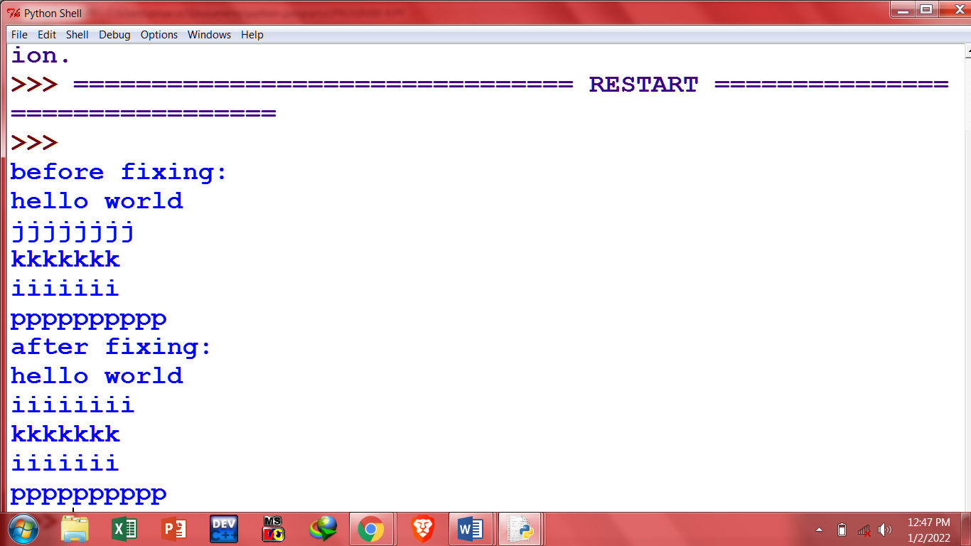

**notepad file words.txt-**

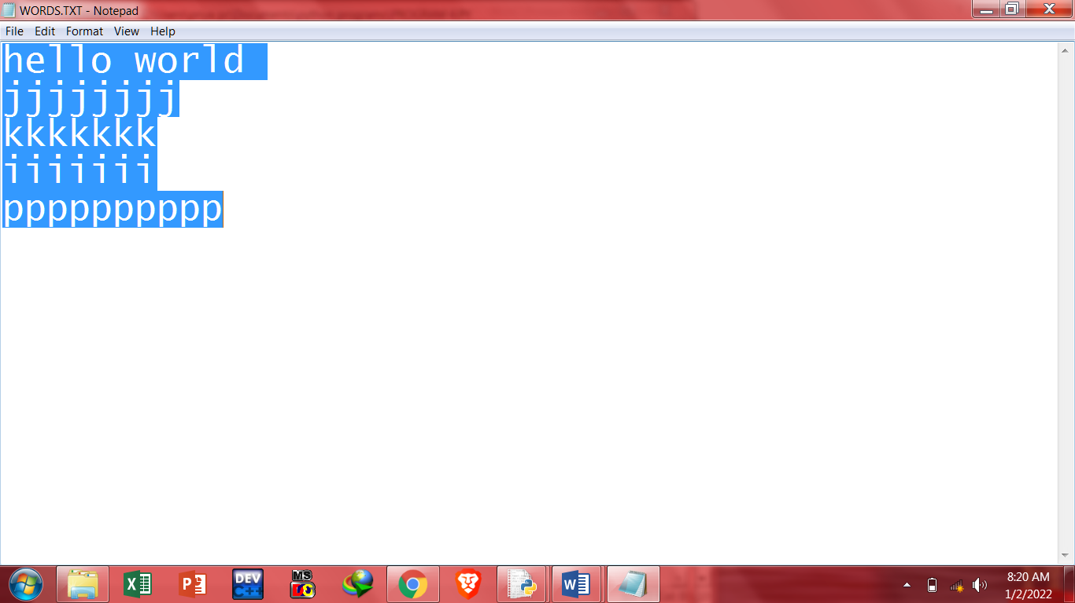

**5.Write a function display_words() in python to read lines from a text file "article.txt", and display those words, which are less than 6 characters.**

def display_word():

f=open("ARTICLE.TXT","r")

str=f.read()

wordlist=str.split(" ")

for x in wordlist:

if(len(x)<6):

print(x)

display_word()

f.close();

**output-**

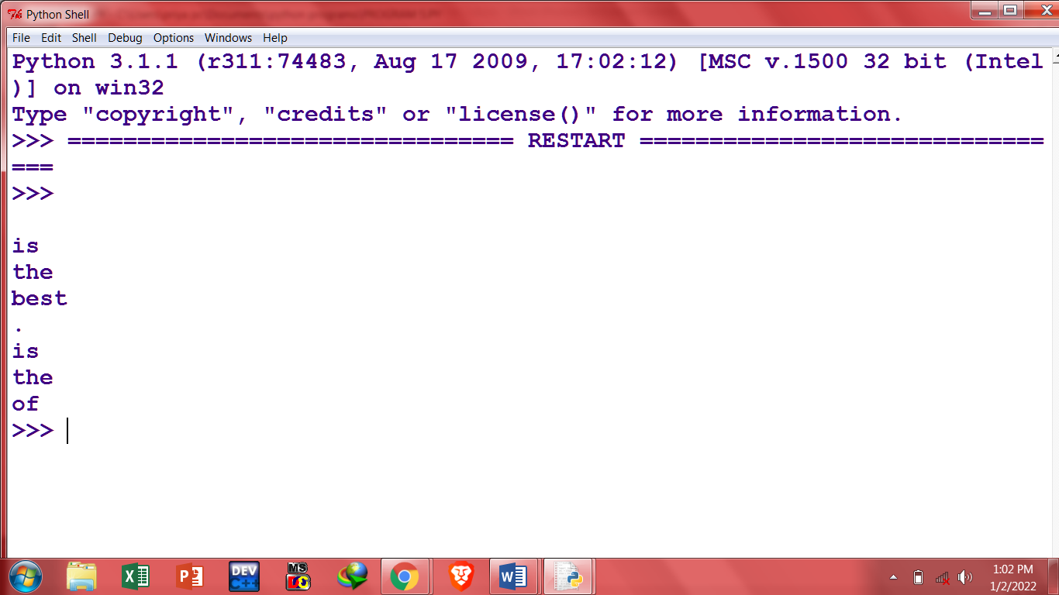

**6.Write a function in python to count the number of lines from a text file "article.txt" which is not starting with an alphabet "T".**

f = open("WORDS.TXT", "r")

str=f.readlines()

count=0

for x in str:

if(not x.startswith("T")):

count+=1

print(count)

f.close();

**output-**

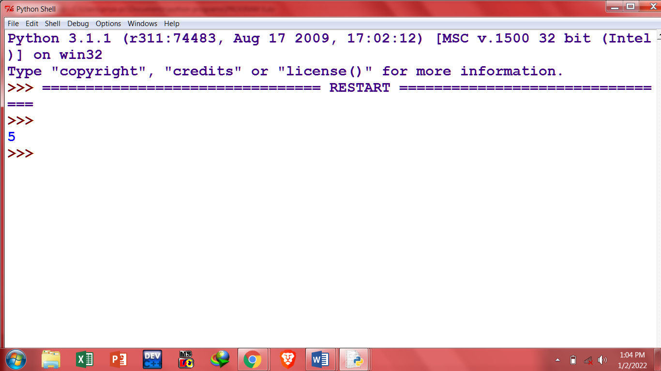

**7. Write a program to arrange all the sub tuples of the tuples in increasing order and store them in another tuple. T1=((1,2,3),(94,23),(67,95,13)) # original tuple T2=((1,2,3),(23,94),(13,67,95)) #new tuple**

t1=((1,2,3),(94,23),(67,95,13))

lst=[]

for x in t1:

lst.append(tuple(sorted(x)))

t2=tuple(lst)

print(t2)

**output-**

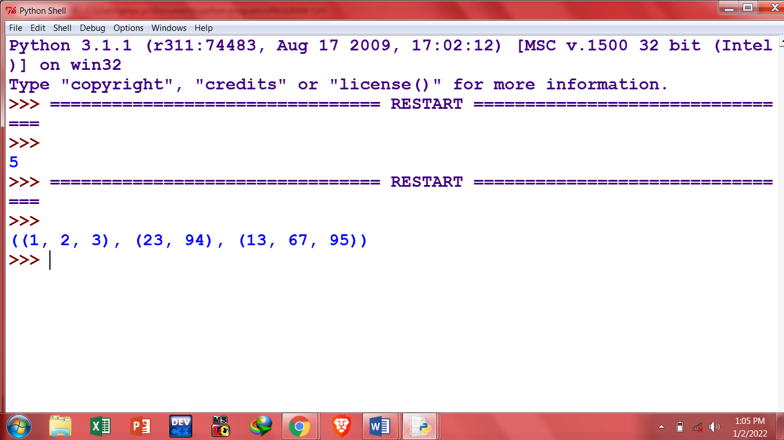

**8.Write a program to accept a number from the user and create a tuple containing all factors of a number. Eg: Enter a number: 9 T1=(1,3,9)**

n=int(input("Enter a number:"))

factList=[]

for i in range (1,n+1):

if(n%i==0):

factList.append(i)

t2=tuple(factList)

**output-**

Enter a number:12

>>>

((1, 2, 3), (23, 94), (13, 67, 95))

>>>

**9. Write a Python program to compute the sum of all the elements of each tuple stored inside a list of tuples. Original list of tuples: [(1, 2), (2, 3), (3, 4)]**

**Sum of all the elements of each tuple stored inside the said list of tuples: [3, 5, 7]**

data=[(1, 2), (2, 3), (3, 4,78)]

newList=[]

for x in data:

sum=0

for y in x:

sum+=y

newList.append(sum)

print(newList)

**output-**

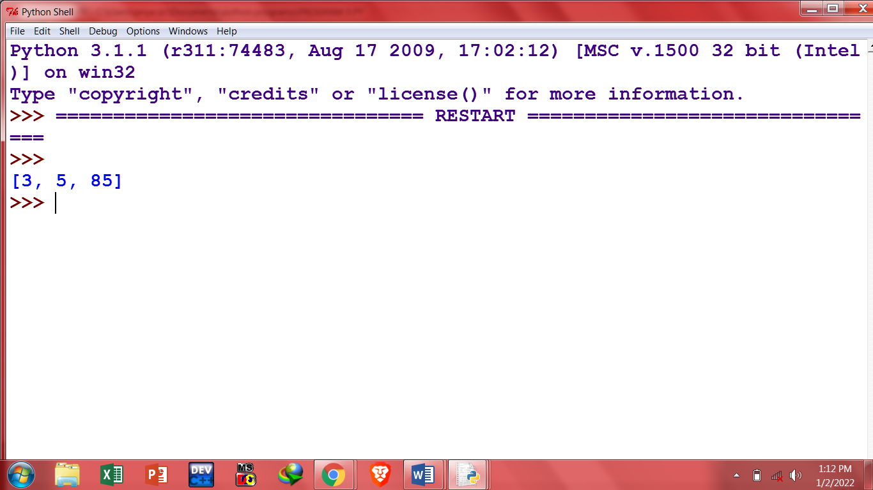

**10. Write a Python program to convert a given list of tuples to a list of lists.**

**Original list of tuples: [(1, 2), (2, 3, 5), (3, 4), (2, 3, 4, 2)] Convert the said list of tuples to a list of lists: [[1, 2], [2, 3, 5], [3, 4], [2, 3, 4, 2]]**

data=[(1, 2), (2, 3, 5), (3, 4), (2, 3, 4, 2)]

newData=[]

for x in data:

newData.append(list(x))

print(newData)

**output-**

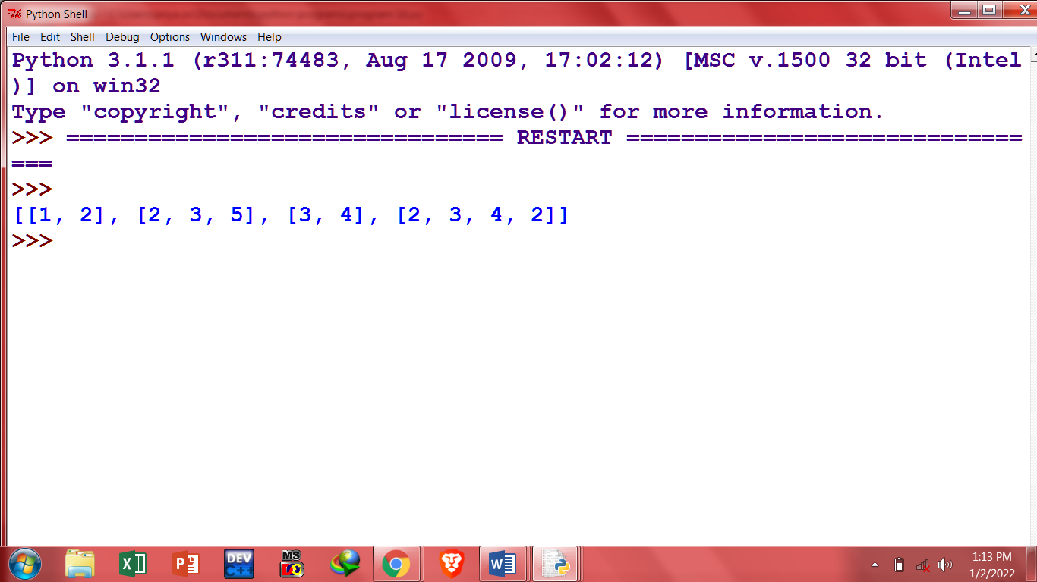

**11.Write a Python program to replace the last element in a list with another list. Sample data : [1, 3, 5, 7, 9, 10], [2, 4, 6, 8] Expected Output: [1, 3, 5, 7, 9, 2, 4, 6, 8]**

d1=[1, 3, 5, 7, 9, 10]

d2=[2, 4, 6, 8]

last=len(d1)

d1.pop()

for x in d2:

d1.append(x)

print(d1)

**OUTPUT-**

**-** 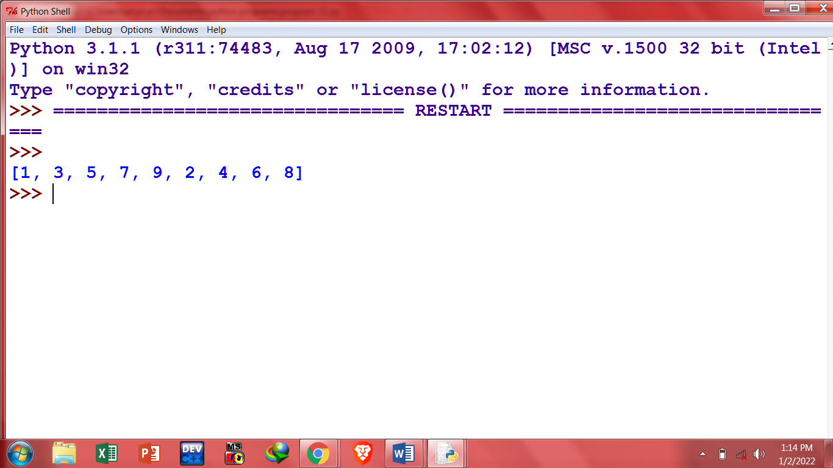

**12.Write a Python program to scramble the letters of string in a given list. Original list: ['Python', 'list', 'exercises', 'practice', 'solution'] After scrambling the letters of the strings of the said list: ['tnPhyo', 'tlis', 'ecrsseiex', 'ccpitear', 'noiltuos']**

from random import shuffle

def shuffle_word(text_list):

text_list = list(text_list)

shuffle(text_list)

return ''.join(text_list)

text_list = ['Python', 'list', 'exercises', 'practice', 'solution']

print("Original list:")

print(text_list)

print("\nAfter scrambling the letters of the strings of the said list:")

result = [shuffle_word(word) for word in text_list]

print(result)

**output-**

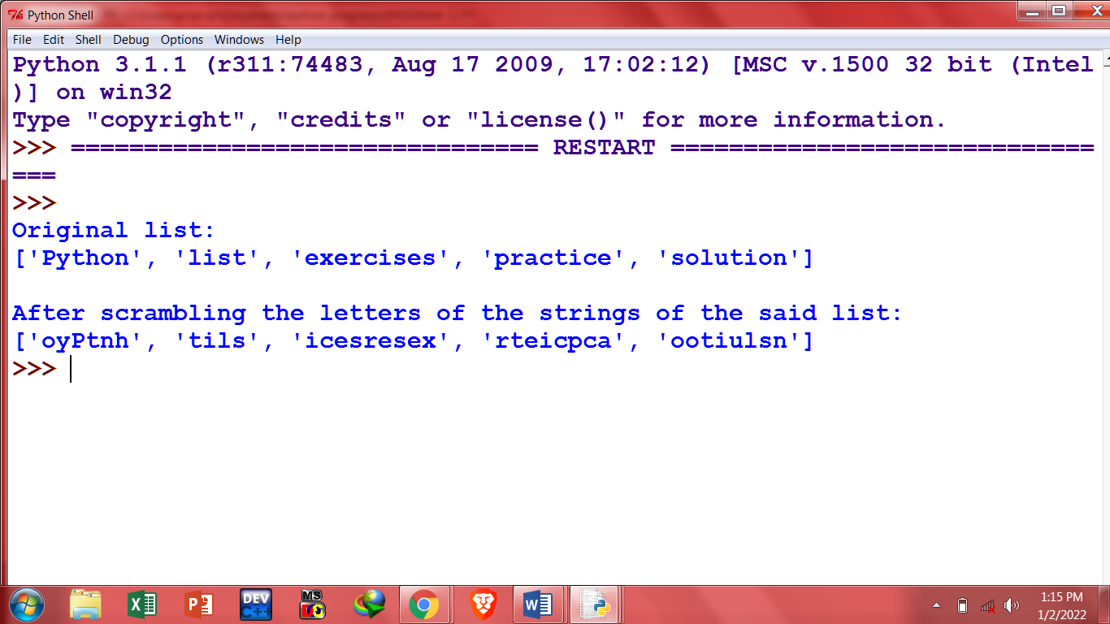

**13. Write a program that has class store which keeps a record of code and price of each product. Display a menu of all products to the user and prompt him to enter the quantity of each item required. generate a bill and display the total amount.**

class MyStore:

__prod_code=[]

__cost_price=[]

__prod_quant=[]

def getdata(self):

self.p = int(input("Enter no. of products you need to store: "))

for x in range(self.p):

self.__prod_code.append(int(input("Enter Product Code: ")))

self.__cost_price.append(int(input("Enter Cost price: ")))

def display(self):

print("Stock in Stores")

print("----------------------------------------------------------")

print("Product Code \t Cost Price")

print("----------------------------------------------------------")

for x in range(self.p):

print(self._prod_code[x], "\t\t\t\t", self._cost_price[x])

print("----------------------------------------------------------")

def print_bill(self):

total_price = 0

for x in range(self.p):

q=int(input("Enter the quantify for the product code %d : "%self.__prod_code[x]))

self.__prod_quant.append(q)

total_price = total_price +self._cost_price[x]*self._prod_quant[x]

print("Invoice Receipt")

print("-----------------------------------------------------------------------------")

print("Product Code\t Cost Price\t Quantity \t Total Amount")

print("-----------------------------------------------------------------------------")

for x in range(self.p):

print(self.__prod_code[x], "\t\t\t\t",

self.__cost_price[x], "\t\t\t\t",

self.__prod_quant[x], "\t\t\t\t",

self._prod_quant[x]*self._cost_price[x])

print("-----------------------------------------------------------------------------")

print("Total Amount = ", total_price)

S=MyStore()

S.getdata()

S.display()

S.print_bill()

**Output-**

**14. Write a class that stores a string and all its status details such as number of uppercase characters, vowels, consonants, spaces, etc.**

class String:

def _init_(self):

self.uppercase=0

self.lowercase=0

self.vowels=0

self.consonants=0

self.spaces=0

self.string=""

def getstr(self):

self.string=str(input("Enter a String: "))

def count_upper(self):

for ch in self.string:

if (ch.isupper()):

self.uppercase+=1

def count_lower(self):

for ch in self.string:

if (ch.islower()):

self.lowercase+=1

def count_vowels(self):

for ch in self.string:

if (ch in ('A', 'a', 'e', 'E', 'i', 'I', 'o', 'O', 'l', 'L')):

self.vowels+=1

def count_consonants(self):

for ch in self.string:

if (ch not in ('A', 'a', 'e', 'E', 'i', 'I', 'o', 'O', 'l', 'L')):

self.consonants+=1

def count_space(self):

for ch in self.string:

if (ch==" "):

self.spaces+=1

def execute(self):

self.count_upper()

self.count_lower()

self.count_vowels()

self.count_consonants()

self.count_space()

def display(self):

print("The given string contains...")

print("%d Uppercase letters"%self.uppercase)

print("%d Lowercase letters"%self.lowercase)

print("%d Vowels"%self.vowels)

print("%d Consonants"%self.consonants)

print("%d Spaces"%self.spaces)

S = String()

S.getstr()

S.execute()

S.display()

**Output-**

**15. Write a program that has an abstract class Polygon. Derive two classes Rectangle and Triangle from Polygon and write methods to get the details of their dimensions and hence calculate the area.**

class Polygon:

width=0

height=0

def setData(self,w,h):

self.width=w

self.height=h

def getData(self):

print("width:",self.width)

print("height:",self.height)

class Rectangle(Polygon):

def area(self):

return self.width*self.height

class Triangle(Polygon):

def area(self)

return self.width*self.height/2

rect=Rectangle()

tri=Triangle()

tri.setData(34,56)

rect.setData(5,6)

print("Area of rectangle is",rect.area())

print("Area of triangle is",tri.area())

